**HackX_2 Bot**

All Hackathon event involves team members to collaborate with each other.  
In HackX the members can join individually, duo or in a squad. - [Link](https://www.scaler.com/event/scaler-hackx-2-0/)  
  
  
  
  
HackXbot does the same by creating and destroying voice channels, dynamically.

Let me elaborate on that…  
  
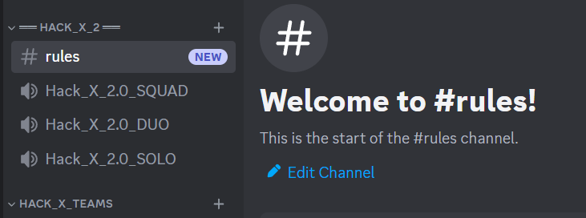

You see there is a category called “---Hack_X_2---” which contains one text channel for mentioning rules (how to use this bot) and three voice channels called: -

Hack_X_2.0_SQUAD

Hack_X_2.0_DUO

Hack_X_2.0_SOLO

Here is the interesting part…

*Clicking/Selecting any of these channels doesn’t let you join them, but creates* ***new voice channel*** *with your unique discord user name as the name of the channel and* ***max number of members that can join limited to your choice****.*

Here is an example: -

Me selecting Hack_X_2.0_DUO - creates voice channel with 2 member capacity

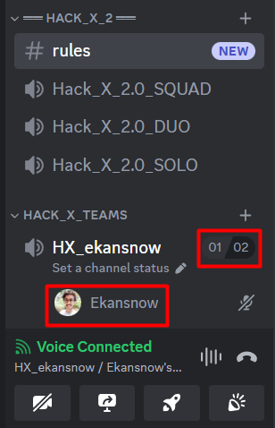

Another member selects Hack_X_2.0_SQUAD -creates voice channel with 4 cap.

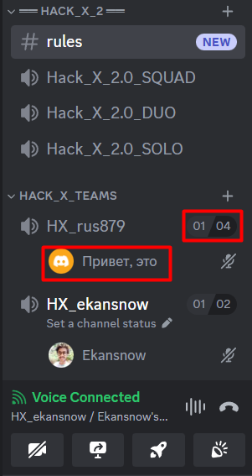

Notice how new channels are created and destroyed within “HACK_X_TEAMS” section. This will keep the server highly organized.  
Channel destruction happens as soon as the host (member who selected Hack_X_2.0 voice channel) leaves the channel.

**Applications: -**

The possibilities of application of these features are endless. We can use them in **hackathon, gaming events, code reviews, study partner** etc.  
These would create a great section within the server for individuals to collaborate, leading to productive interactions and beautiful memories.

Rest of the functionality remains the same as that of a voice channel  
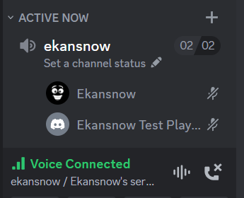 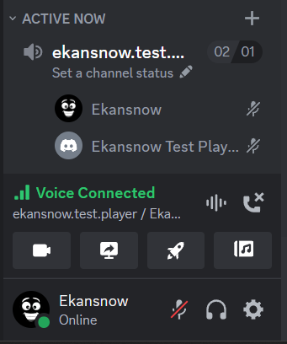

Admins can bypass the maximum number of people allowed to join – “rule”.  
See the image on the right (02/01)  
  
The code has been uploaded to my GitHub profile.  
<https://github.com/Ekansnow/HackX_2.0>  
  
Check the comments in the code to explore bonus functionalities like  
Deletion of inactive voice channels.  
Delete Voice Channel when its creator leaves it.  
Don’t allow members to switch between hack_x voice channels directly.  
  
**Thank You!**